| **Table 1: Democracy and Pollution Outsourcing** | | | | |
| --- | --- | --- | --- | --- |
|  | **Model 1** | **Model 2** | **Model 3** | **Model 4** |
| Democracy (Within) | 0.10* |  | 0.16*** | 0.31*** |
|  | (0.06) |  | (0.05) | (0.05) |
| Democracy (Between) | 3.18*** |  | 0.65** | 0.65** |
|  | (0.55) |  | (0.30) | (0.31) |
| Population (Within) |  | -0.42*** | -0.43*** | -0.49*** |
|  |  | (0.05) | (0.05) | (0.05) |
| Population (Between) |  | 0.83*** | 0.83*** | 0.85*** |
|  |  | (0.04) | (0.04) | (0.04) |
| GDP per capita (Within) |  | -1.04*** | -1.07*** | 0.16 |
|  |  | (0.11) | (0.11) | (0.13) |
| GDP per capita2 (Within) |  | 0.09*** | 0.09*** | 0.02** |
|  |  | (0.01) | (0.01) | (0.01) |
| GDP per capita (Between) |  | 0.86* | 0.87* | 1.12** |
|  |  | (0.50) | (0.50) | (0.52) |
| GDP per capita2 (Between) |  | 0.01 | 0.00 | -0.01 |
|  |  | (0.03) | (0.03) | (0.03) |
| Constant | 1.33*** | -17.90*** | -17.97*** | -20.25*** |
|  | (0.32) | (2.23) | (2.20) | (2.30) |
| Controls | No | Yes | Yes | Yes |
| Country-FE | Yes | Yes | Yes | Yes |
| Year-FE | Yes | Yes | Yes | Yes |
| AIC | 2337.50 | 947.71 | 941.51 | -1173.02 |
| BIC | 2527.30 | 1161.14 | 1167.49 | -1007.31 |
| Log Likelihood | -1138.75 | -439.86 | -434.76 | 614.51 |
| Num. obs. | 4133 | 3933 | 3933 | 2747 |
| Num. groups: Country | 163 | 161 | 161 | 155 |
| Var: Country (Intercept) | 3.32 | 0.66 | 0.65 | 0.65 |
| Var: Residual | 0.07 | 0.06 | 0.06 | 0.03 |
| Notes: ***p < 0.01; **p < 0.05; *p < 0.1 | | | | |

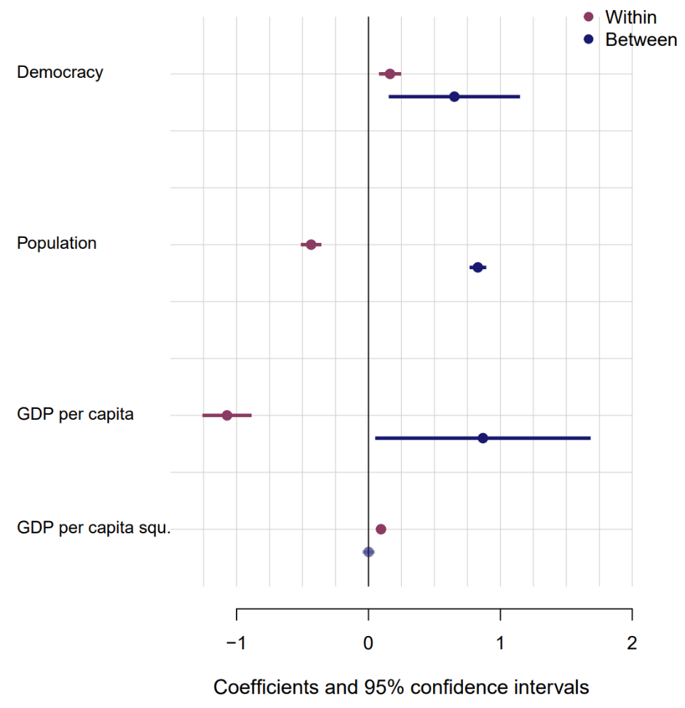

also ich weiß dass ich da auch schon viel mit rumgespielt habe und ich bin mir nicht ganz sicher ob ich auf die Lösung gekommen bin, glaube aber eher nicht. Mein Rätsel war wie ich es schaffe eine Regression “a + b + a*b + FE” mit de-meaned Versionen von a und b zu reproduzieren, also sowas wie “demeaned(a) + demeaned(b) + demeaned(a)*demeaned(b)” — und das hat auch nicht wirklich geklappt. Ich glaube es hat was damit zu tun dass die IVs in einer Regression mit mehreren IVs ja residualized sind und de-meaning dann nicht ausreicht? Aber ich habe es auch nicht wirklich geschafft

ich habe auf jeden Fall sehr viel und unterschiedliche REihenfolgen von de-meaning ausporbiert

uuh her ist vielleicht die Lösung: <https://www.diw.de/documents/publikationen/73/diw_01.c.594675.de/dp1748.pdf>

[10:47 Uhr](https://aqm2022.slack.com/archives/D032ZLUMZFS/p1717750077328119)

wenn ich es richtig verstehe sagt er dass man a und b de-meanen soll, dann die interaktion berechnen, und die dann *nochmal* de-meanen. Also:  
demeaned(a) + demeand(b) + **demeand[**demeaned(a)*demeaned(b) **]**

| **Table 2: Environmental Performance and Pollution Outsourcing** | | | | |
| --- | --- | --- | --- | --- |
|  | **Model 5** | **Model 6** | **Model 7** | **Model 8** |
| Pollution Outsourcing (Within) | 0.07*** | 0.09*** |  | 0.04*** |
|  | (0.01) | (0.01) |  | (0.01) |
| Pollution Outsourcing (Between) | 0.22*** | 0.30*** |  | 0.02 |
|  | (0.03) | (0.08) |  | (0.05) |
| Democracy (Within) | 0.17*** | 0.25*** |  | 0.21*** |
|  | (0.03) | (0.03) |  | (0.03) |
| Democracy (Between) | 0.62** | 0.97** |  | -0.41* |
|  | (0.25) | (0.40) |  | (0.22) |
| Democracy x Pollution Outsourcing (W) |  | -0.05*** |  | -0.04*** |
|  |  | (0.01) |  | (0.01) |
| Democracy x Pollution Outsourcing (B) |  | -0.14 |  | -0.13** |
|  |  | (0.12) |  | (0.07) |
| Population (Within) |  |  | 0.23*** | 0.23*** |
|  |  |  | (0.02) | (0.02) |
| Population (Between) |  |  | 0.04* | 0.09** |
|  |  |  | (0.02) | (0.04) |
| GDP per capita (Within) |  |  | 0.06 | 0.04 |
|  |  |  | (0.05) | (0.05) |
| GDP per capita2 (Within) |  |  | 0.02*** | 0.02*** |
|  |  |  | (0.00) | (0.00) |
| GDP per capita (Between) |  |  | 0.54** | 0.39 |
|  |  |  | (0.26) | (0.25) |
| GDP per capita2 (Between) |  |  | 0.00 | 0.02 |
|  |  |  | (0.02) | (0.01) |
| Constant | 0.33** | 0.17 | -3.80*** | -4.27*** |
|  | (0.13) | (0.20) | (1.13) | (1.23) |
| Controls | No | Yes | Yes | Yes |
| Country-FE | Yes | Yes | Yes | Yes |
| Year-FE | Yes | Yes | Yes | Yes |
| AIC | -4090.29 | -4095.10 | -4914.28 | -4969.57 |
| BIC | -3889.44 | -3881.70 | -4700.88 | -4718.51 |
| Log Likelihood | 2077.14 | 2081.55 | 2491.14 | 2524.78 |
| Num. obs. | 3930 | 3930 | 3930 | 3930 |
| Num. groups: Country | 161 | 161 | 161 | 161 |
| Var: Country (Intercept) | 0.56 | 0.56 | 0.17 | 0.14 |
| Var: Residual | 0.01 | 0.01 | 0.01 | 0.01 |
| Notes: ***p < 0.01; **p < 0.05; *p < 0.1 | | | | |

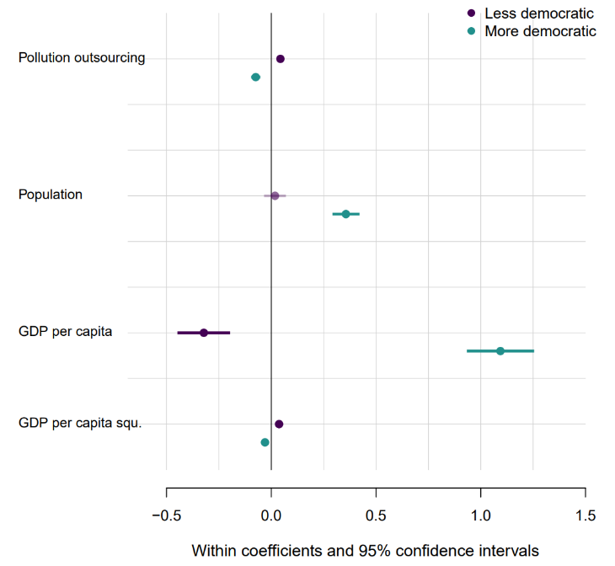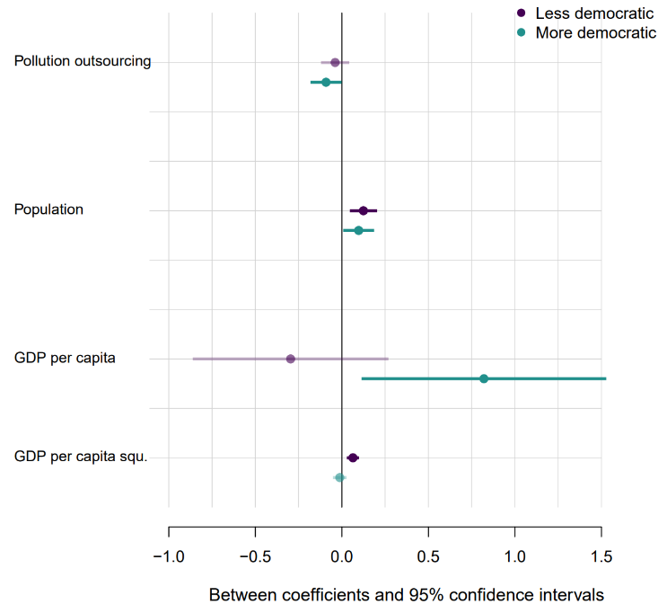

Left-hand panel: This plot visually summarizes the main findings of the model on the split sample for the within-effect of *Pollution Outsourcing* on CO2 emission levels (within countries). In less democratic settings, an increase in *Pollution Outsourcing* in comparison to the long-term average of a country is associated with an increase in CO2 emissions. For less democratic settings, the picture is reversed: Increases in Pollution Outsourcing relative to the country-mean are associated with decreases in CO2 emissions.

Right-hand panel: This plot visually summarizes the main findings of the model on the split sample for the between-effect of *Pollution Outsourcing* on CO2 emission levels (between countries). In the set of less democratic countries, more outsourcing is not significantly associated with CO2 emissions. In the set of more democratic countries, more outsourcing is negatively associated with lower CO2 emission levels.

Why do we have different models? As interactions in within-between random effects models are very complex, we opt for working with a sample split to demonstrate the diverging effects of outsourcing in more vs. less democratic settings. We split the sample in two different manners for the within- and the between-effects. For the within-effects, the sample is split in more and less democratic contexts based on the variable *Democracy*. Thereby, every country-year falling below the median of this variable ends up in the lower democracy sample, while country-year observations above or equal to the median comprise the higher democracy sample.

For the between-effects however, we use the median of the mean_democracy variable to do the sample split. Because the observation level is here the country and not the country-year, splitting observations based on the democracy mean per country makes more sense.

Substantively: First differences between

* Pollution outsourcing within (more – less democratic)
* Pollution outsourcing between (more – less democratic)